Purpose: Day 10 Classwork and Assignment
Date: 06/01/2026
Author: Vinayak Majhi
ID: 58618
Batch ID: 25SUB4505 - DATACOM+5G

ClassWork

Q.1 Implement a DynArray class where memory is allocated dynamically.
Use exceptions to handle incorrect array size.

// Purpose: Dynamic Array class with exception handling
// Date: 06/01/2026
// Author: Vinayak Majhi
// ID: 58618
// Batch ID: 25SUB4505 - DATACOM+5G

#include <iostream>
#include <exception>

using namespace std;

class DynArray {
int *arr;
int size;

public:
DynArray(int s) {
if (s <= 0)
throw invalid_argument("Invalid array size");

size = s;
arr = new int[size];
}

void input() {
cout << "Enter " << size << " elements:\n";
for (int i = 0; i < size; i++)
cin >> arr[i];
}

void display() const {
cout << "Array elements: ";
for (int i = 0; i < size; i++)
cout << arr[i] << " ";
cout << endl;
}

~DynArray() {
delete[] arr;
}
};

int main() {
try {
int n;
cout << "Enter array size: ";
cin >> n;

DynArray d(n);
d.input();
d.display();
}
catch (exception &e) {
cout << "Exception caught: " << e.what() << endl;
}

return 0;
}

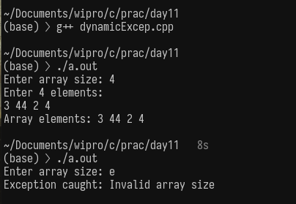

Q 2. Implement a MyString class where memory is allocated dynamically.
Use exceptions to handle incorrect string size.

// Purpose: MyString class with dynamic memory and exception handling
// Date: 06/01/2026
// Author: Vinayak Majhi
// ID: 58618
// Batch ID: 25SUB4505 - DATACOM+5G

#include <cstring>
#include <exception>
#include <iostream>

using namespace std;

class MyString {
char *str;
int len;

public:
MyString(int l) {
if (l <= 0)
throw invalid_argument("Invalid string length");

len = l;
str = new char[len + 1];
str[0] = '\0';
}

void input() {
cout << "Enter string (max " << len << " chars): ";
cin.getline(str, len + 1);
}

void display() const {
cout << "String: " << str << endl;
cout << "Length: " << strlen(str) << endl;
}

~MyString() { delete[] str; }
};

int main() {
try {
int size;
cout << "Enter string size: ";
cin >> size;
cin.ignore();

MyString s(size);
s.input();
s.display();
} catch (exception &e) {
cout << "Exception caught: " << e.what() << endl;
}

return 0;
}
